**CARE HAVEN**

**Project Abstract**

This project introduces a web-based system to enhance the management and collaboration between users and orphanages. The system features two main roles:

User and Admin, each with distinct functionalities tailored to streamline interactions. Users can browse orphanages, donate directly to their chosen orphanage, and share their feedback to support continuous improvement. They also retain the ability to delete their feedback, ensuring control over their contributions.

Admins oversee the operational aspects of the system. They manage orphanage profiles by creating and deleting entries, handle donation records, and view user feedback to monitor community engagement.

**Version 1.0**

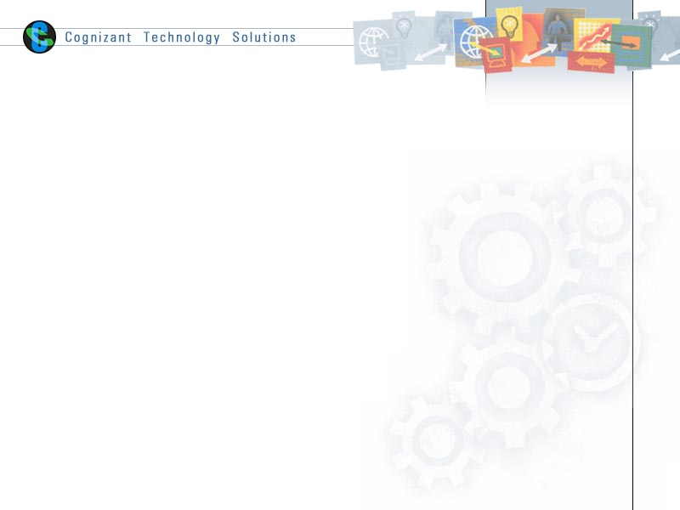

|  |  |  |  |
| --- | --- | --- | --- |
|  | Prepared By / Last Updated By | Reviewed by | Approved By |
| Name | Mridul Kanti | Sravanthi Venishetty | Sravanthi Venishetty |
| Role | Program Analyst Trainee |  |  |
| Signature |  |  |  |
| Date | 09-01-2025 |  |  |

Table of Contents

1.0 Purpose of this document 4

2.0 Business Case 4

3.0 Appendices 4

3.1 Glossary 4

3.2 Other 4

4.0 Terms & Conditions 5

5.0 Change Log 5

# Purpose of this document

The purpose of Care Haven is to serve as a comprehensive platform that bridges the gap between orphanages and those who wish to support them. It enables donors, volunteers, and orphanage administrators to connect and collaborate effectively. The platform simplifies the donation process, ensuring that resources are delivered efficiently and transparently while allowing donors to track their contributions and understand their impact. Additionally, it provides orphanage administrators with tools to manage resources, monitor donations, and engage with supporters. By fostering a sense of community, raising awareness about the needs of orphanages, and encouraging active participation, Care Haven empowers individuals and organizations to contribute meaningfully to the well-being and future of orphaned children worldwide.

# Business Case

**Executive Summary:** Care Haven aims to develop a web-based system to enhance the management and collaboration between users and orphanages. By streamlining interactions, facilitating donations, and enabling continuous feedback, the system benefits both users and orphanages. Users can directly donate and share their experiences, while admins efficiently manage orphanage profiles and donation records.

**Problem Statement:** Orphanages often face challenges in managing donations, engaging with the community, and maintaining transparent operations. Users struggle to find reliable platforms to support orphanages and share their experiences. The current manual processes are inefficient and prone to errors, leading to missed opportunities for support and improvement.

**Project Objectives:**

* **Improve Donation Management:** Provide a seamless platform for users to donate directly to orphanages of their choice.
* **Enhance User Engagement:** Enable users to browse orphanages, share feedback, and maintain control over their contributions.
* **Streamline Administrative Tasks:** Allow admins to create and manage orphanage profiles, handle donation records, and monitor user feedback.

**Benefits:**

* **For Users:**
  + Easy access to information about orphanages
  + Direct and secure donation process
  + Ability to provide feedback and see the impact of their contributions
* **For Orphanages:**
  + Increased visibility and support
  + Efficient management of profiles and donations
  + Valuable insights from user feedback for continuous improvement

**Scope:**

* **User Features:**
  + Browse orphanages
  + Make donations
  + Share and delete feedback
* **Admin Features:**
  + Create and manage orphanage profiles
  + Handle donation records
  + View and analyze user feedback

**Cost-Benefit Analysis:**

* **Costs:**
  + Development and maintenance of the web-based system
  + Training for admin users
  + Marketing and outreach to raise awareness
* **Benefits:**
  + Increased donations and community engagement
  + Improved operational efficiency for orphanages
  + Enhanced user satisfaction and trust

**Risks and Mitigations:**

* **Risk:** Security and data privacy concerns
  + **Mitigation:** Implement robust security measures and comply with data protection regulations
* **Risk:** User adoption and engagement
  + **Mitigation:** Conduct user training and provide ongoing support

**Timeline:**

* **Phase 1:** Requirement Gathering and Planning (2 Weeks)
* **Phase 2:** System Design and Development (1 month)
* **Phase 3:** Testing and Quality Assurance (2 Weeks)
* **Phase 4:** Deployment (1 Week)
* **Phase 5:** Monitoring and Continuous Improvement (Ongoing)

# Appendices

## Glossary

|  |  |
| --- | --- |
| **Acronyms** | **Definitions** |
| **Angular Framework**: | Platform for building Frontend. |
| **ASP.NET:** | Server-side framework for creating dynamic web pages and services. |
| **MS SQL:** | Relational database management system by Microsoft. |
| **JWT:** | Token for secure information transfer between parties, often used for authentication. |
| **EF Core:** | Cross-platform ORM for .NET, simplifying data access with .NET objects. |
| **NUnit Test:** | Unit-testing framework for .NET languages, used for verifying code quality. |

## Other

# Terms & Conditions

***Disclaimer: Please do not circulate or distribute this document outside of Cognizant Network, We have a Zero Tolerance Policy. Kindly adhere to 100% Compliance at all times.***

# Change Log

*Please note that this table needs to be maintained even if a Configuration Management tool is used.*

|  |  |  |  |  |
| --- | --- | --- | --- | --- |
| Version Number | Changes made | | | |
| V<n.n> | *<If the change details are not explicitly documented in the table below, reference should be provided here>* | | | |
| Page no | Changed by | Effective date | Changes effected |
|  |  |  |  |
|  |  |  |  |
|  |  |  |  |
|  |  |  |  |